# **In-Lab Tasks**

**Muhammad Raahim**

**24k-0543**

#include <iostream>

#include <string>

using namespace std;

string eventA[5];

string eventB[5];

void registration() {

cout << "SIGN UP FOR EVENT A\n" << endl;

cout << "type '0' to stop" << endl;

for (int i = 0; i < 5; i++) {

cout << "Participant " << i + 1 << " for Event A: " << endl;

cin >> eventA[i];

if (eventA[i] == "0") {

break;

}

}

cout << "\nSIGN UP FOR EVENT B\n" << endl;

cout << "type '0' to finish" << endl;

for (int i = 0; i < 5; i++) {

cout << "Participant " << i + 1 << " for Event B: " << endl;

cin >> eventB[i];

if (eventB[i] == "0") {

break;

}

}

}

void search() {

string name;

int a = 0, b = 0;

cout << "\nSearch participant: " << endl;

cin >> name;

for (int i = 0; i < 5; i++) {

if (eventA[i] == name) {

a = 1;

}

if (eventB[i] == name) {

b = 1;

}

}

if (a == 1 && b == 1) {

cout << name << " took part in both events.\n" << endl;

}

else if (a == 1 && b == 0) {

cout << name << " took part in Event A.\n" << endl;

}

else if (a == 0 && b == 1) {

cout << name << " took part in Event B.\n" << endl;

}

else if (a == 0 && b == 0) {

cout << name << " did not tak part in any event.\n" << endl;

}

}

int totaldonations() {

int countA = 0;

int countB = 0;

for (int i = 0; i < 5; i++) {

if (eventA[i] == "0") {

break;

} else {

countA++;

}

}

for (int i = 0; i < 5; i++) {

if (eventB[i] == "0") {

break;

} else {

countB++;

}

}

int total = countA + countB;

int donations = total * 10;

return donations;

}

void reverseA() {

cout << "\nEVENT A in reverse order\n";

for (int i = 4; i >= 0; i--) {

if (eventA[i] != "0") {

cout << eventA[i] << endl;

}

}

}

void reverseB() {

cout << "\nEVENT B in reverse order\n";

for (int i = 4; i >= 0; i--) {

if (eventB[i] != "0") {

cout << eventB[i] << endl;

}

}

}

void barchart() {

int countA = 0;

int countB = 0;

for (int i = 0; i < 5; i++) {

if (eventA[i] == "0") {

break;

} else {

countA++;

}

}

for (int i = 0; i < 5; i++) {

if (eventB[i] == "0") {

break;

} else {

countB++;

}

}

cout<<"\nBar Graph:\n";

cout << "EVENT A: ";

for (int i = 0; i < countA; i++) {

cout << "*";

}

cout << "\n";

cout << "EVENT B: ";

for (int i = 0; i < countB; i++) {

cout << "*";

}

}

int main() {

registration();

search();

cout<<"\nTotal donations: "<<totaldonations()<<endl;

reverseA();

reverseB();

barchart();

}

**Output:**

Task 1

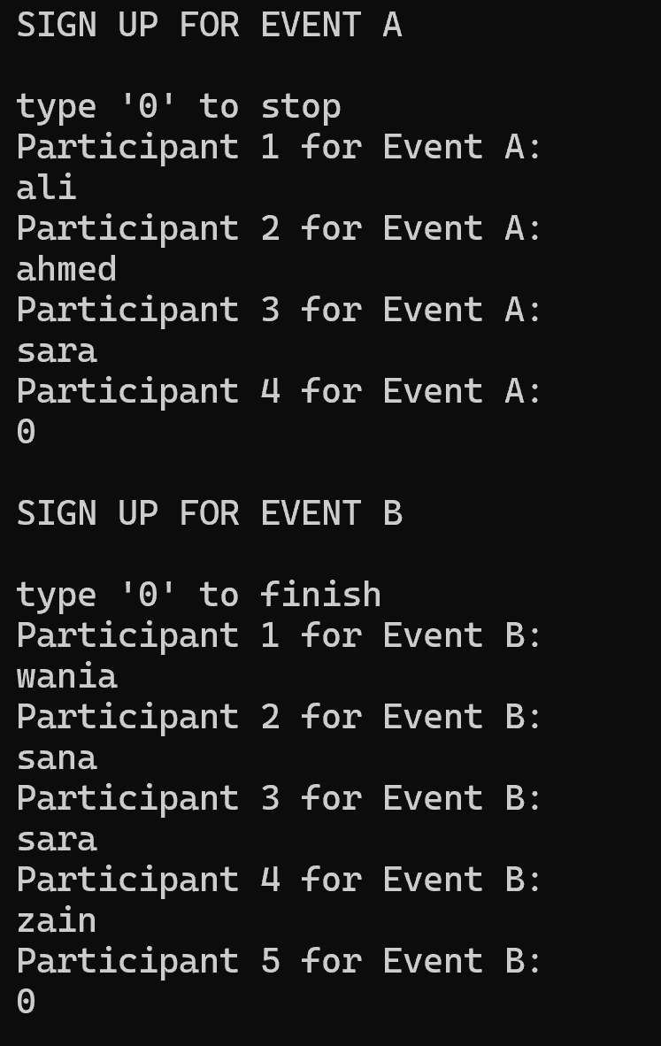

Task 2

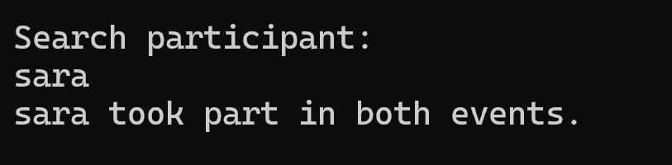

Task 3



Task 4

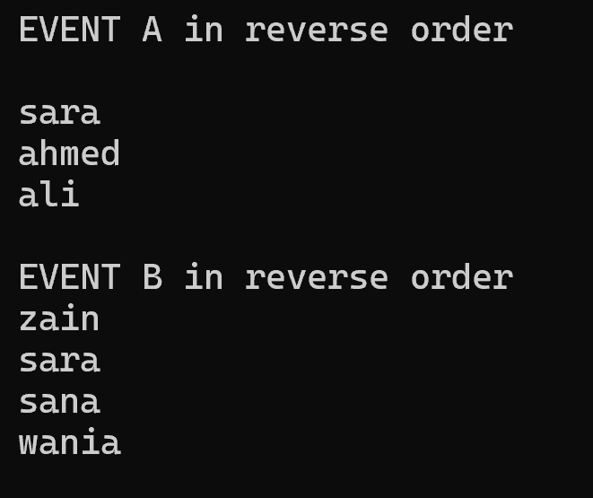

Task 5

